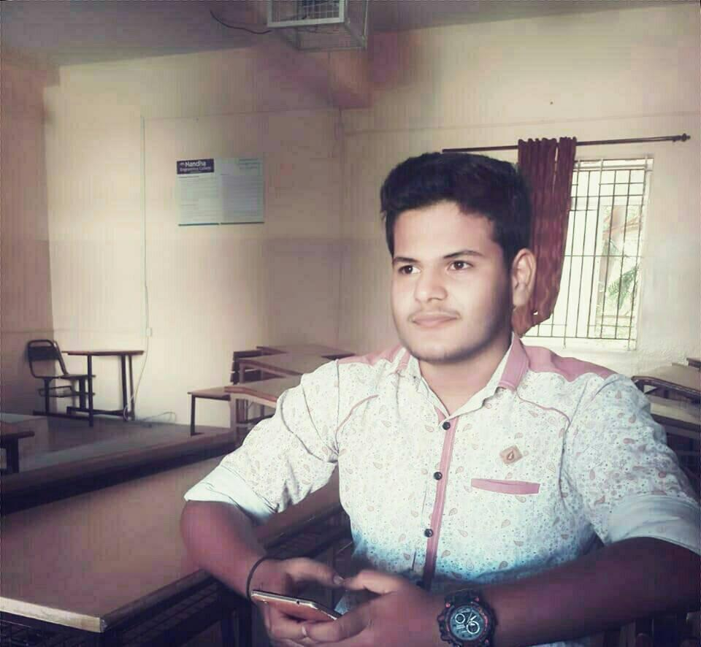**PRAVEEN KUMAR S**

S/o Sakthivel,

5th street B-Tex(opp),

Chandrapuram,

Tirupur-641608

**E-mail:** [praveenkumar.17cs077@nandhaengg.org](mailto:praveenkumar.17cs077@nandhaengg.org) ,

[spraveenpk077@gmail.com](mailto:spraveenpk077@gmail.com)

**Phone / Skype no**: 9585571635

**Telegram**: <https://t.me/spraveenpk> @spraveenpk

**Salesforce:** <https://trailblazer.me/id/spraveenpk>

**Facebook**: <https://www.facebook.com/spraveenrs>

**Github:** <https://github.com/spraveenpk>

Objectives

Seeking a career that is challenging and interesting and lets me work on the leading areas of technology, a job that gives me opportunities to learn, innovate and enhance my skills and strengths with company goals and objectives.

Education

|  |  |  |  |  |
| --- | --- | --- | --- | --- |
| Course | School / Institution | Board /  University | Year of passing | Percentage/ CGPA |
| 10th | Velavan Matric Hr sec school-TUP | State Board | 2015 | 905 |
| 12th | Velavan Matric Hr sec school-TUP | State Board | 2017 | 74.5% |
| UG | Nandha Engineering college- Erd | Anna university | 2021 | 7.5CGPA |

Achievements:

- Got 1st place in DEBUGGING at NEC.

- Got 1st in volley ball in VMHS.

- Got Merit in Kyu at Shito ryu karate.

- Got 3rd place in shadow art in NEC.

- Trailhead **Ranger** in salesforce.

Academic Activties:

- Participated in "Effective Public Speaking " in Nandha Engineering College by JCI Club Erode Galaxy.

-6 days Multi-media workshop by APEX INSTUTUTE OF MULTIMEDIA at Janson Institute of Technology, Coimbatore.

- Got B grade in KPR Talent Test.

- Participant in Internal hackathon for smart Indian hackathon 2020.

Technical Skills:

- Programming languages: python

- Operating System: Windows, Phoenix OS

- Modeling software usage: AutoCAD (planning) & Coral Draw

Mini Project

**Title:** BLOOD BANKING

**Description:** The main objective of the project is to add blood details of persons when patient need blood it checks availability nearby locations.

**Title:** Textile Billing System

**Description:** The main objective of the project is to make bill and save purchase details in the software.

Technical Presentation

-Participated in National level technical symposium in Kumaraguru College of Technology in 2018.

-Participated in “Yugam” in KCT Student Events.

Extra Curricular Activities

Short film Making and Photography

Strength

Ability to learn.

Efficient leader and Good Team player.

Skills

Ability to survive in all kind of situations.

Personal Details

Father’s Name: Sathivel.R

Date of Birth: 20.09.1999

Gender: Male

Nationality: Indian

Marital Status: Single

Languages known: Tamil, English (To Speak, Read and Write)

Declaration

I hereby declare that the details furnished above are true to the best of my knowledge and belief.

Place: **Tirupur**

Praveenkumar S